2026 OBCA All-Star Weekend
Hamilton Fieldhouse
University of Central Oklahoma
June 6th, 2026

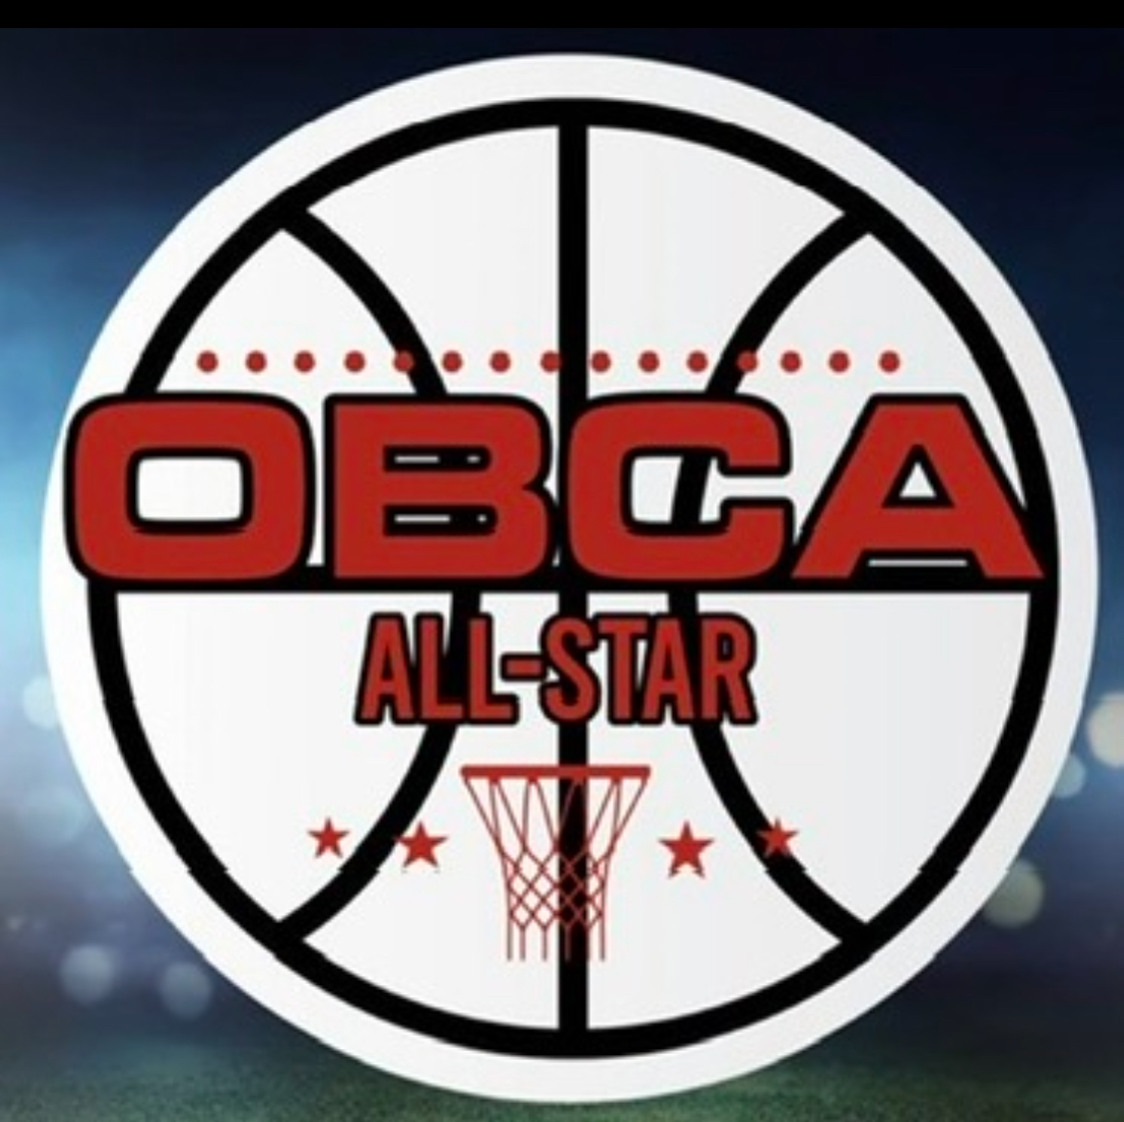




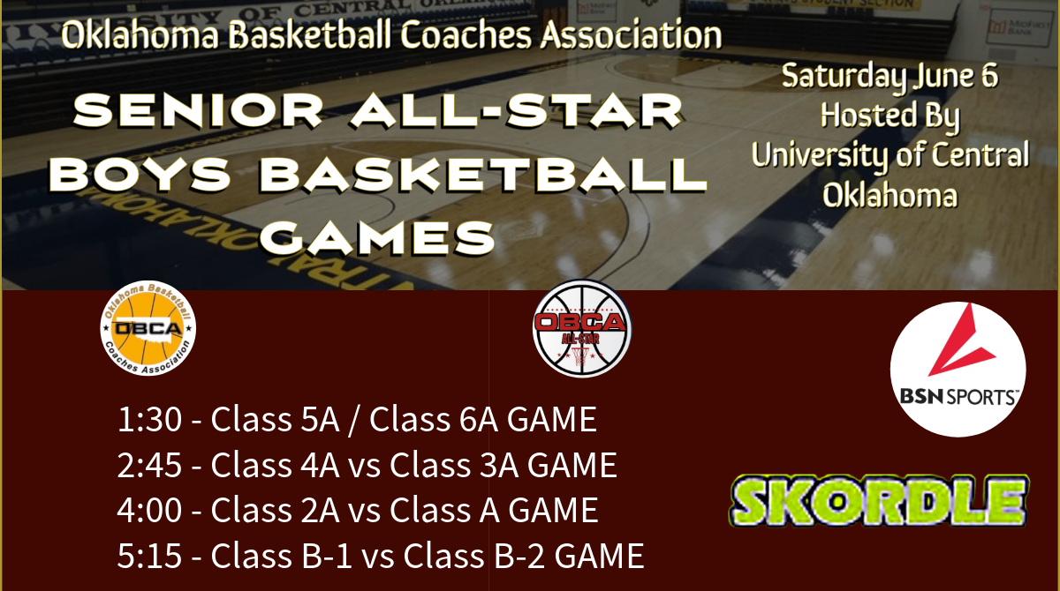



CLASS 6A SENIOR ALL-STAR ROSTER
# | Player Name | School
0 | Nicho N’Gouan | Tulsa Union
22 | Miles Flemons | Tulsa Union
2 | Lucas Leeds | Edmond North
24 | Caison Robinson | Norman
3 | Montrel Pierce‑Combs | Norman
1 | Andrew Reynolds | Mustang
13 | Money Robinson | Edmond Santa Fe
11 | Bode Lashley | Edmond Memorial
0 | Jordan Valentine | Choctaw

Coach Brandon Jackson — Mustang
Coach Jordan Eibel – Mustang

CLASS 5A SENIOR ALL-STAR ROSTER
# | Player Name | School
12 | Isaiah Garrett | Tulsa Memorial
5 | DJ Denson | Midwest City
10 | Jake Rampey | Coweta
3 | Kason Haydon | El Reno
3 | Ricky Bruner III | East Central
21 | Brandon Rogers | Carl Albert
3 | Dylan Scyrkels | Collinsville
3 | Kolton Brammer | Newcastle
33 | Aidon Siqueiros | Shawnee
4 | Kenyon Gabriel | Lawton MacArthur

Coach Rodney Haydon — El Reno
Coach Rob McKinzie — Coweta

CLASS 4A SENIOR ALL-STAR ROSTER
# | Player Name | School
1 | Memphis Burdine | North Rock Creek
20 | Caden Thompson | Inola
2 | Kohen Warden | North Rock Creek
22 | Baker Hoskins | Idabel
25 | Waike Roblyer | Miami
4 | James Huffmyer | Oklahoma Christian School
11 | Jackson Smith | Weatherford
12 | Braden Buckingham | Crossings Christian
13 | Jamel Morris | Douglass
5 | Emory Smalley | Blanchard

Coach Burtchal Griffin — Idabel
Coach Steven Alexander — Douglass

CLASS 3A SENIOR ALL-STAR ROSTER
# | Player Name | School
13 | Raidyn Knight | Roland
20 | Mason Kemp | Roland
3 | Creed Taylor | Lindsay
3 | Cashon Webster | Kellyville
10 | Cooper Westfahl | Chisholm
11 | Jentry James | Eufaula
11 | Brock Rumer | Kingston
15 | Cole Moody | Adair
12 | Hondo Avington Jr. | Daniel Webster
3 | Cade Parker | Stigler

Coach Cole Hibler — Chisholm
Coach Grant Callison — Eufaula

CLASS 2A SENIOR ALL-STAR ROSTER
# | Player Name | School
3 | Denton Forsythe | Dale
2 | Keilan Robinson | Hooker
3 | Carson Schertz | Fairland
3 | Parker Mitchell | Cashion
4 | Wyatt Seeley | Dale
33 | Ace Snowden | Merritt
10 | Kyran Berryhill | Okemah
2 | Mike Piza | Wewoka
11 | Caymen Smith | Latta
1 | Max Stephens | Fairland

Coach Tyler Snowden — Merritt
Coach Trent Storts — Latta

CLASS A SENIOR ALL-STAR ROSTER
# | Player Name | School
33 | Easton Roby | Okarche
11 | Jett Mueggenborg | Okarche
2 | Maddox Replogle | Wright City
13 | Nash Harmon | Cyril
10 | Chase Clark | Okay
11 | Kale Brister | Caddo
11 | Jackson Lohrer | Velma‑Alma
15 | Reed Hellman | Waukomis
5 | Gavin Hamilton | Allen
11 | Kellen Biffle | Cyril

Coach Ty Harmon — Cyril
Coach Kenny McLough — Central High

CLASS B-1 SENIOR ALL-STAR ROSTER
# | Player Name | School
0 | Brett Allen | Hammon
3 | Easton Allen | Binger‑Oney
21 | Kingston Arnold | Calumet
24 | Canyon James | Rattan
42 | Jon Madkins | Varnum
11 | Christian Plumley | Frontier
1 | Ke’shon Shelburn | Wilson (Henryetta)
24 | Kaleb Thiessen | Calumet
23 | Micah Westrope | Pond‑Creek Hunter
1 | Nolan Stewart | Stuart

Coach Taylor Rains — Binger-Oney
Coach Jacob Mayfield – Calumet

CLASS B-2 SENIOR ALL-STAR ROSTER
# | Player Name | School
24 | Brice Bledsoe | Deer Creek‑Lamont
21 | Jace Skocelas | Chattanooga
4 | Jaxson Wade | Granite
10 | Ethan Butler | Cimarron
1 | Bryce Kader | Paden
0 | Cooper Loftin | Chattanooga
0 | Tyler Price | Leedey
12 | Login Sutherland | Deer Creek‑Lamont
1 | Cason Leonard | Eagletown
13 | Gavin Esparza | Granite

Coach Billy Karr — Chattanooga
Coach Curtis Lee — Paden

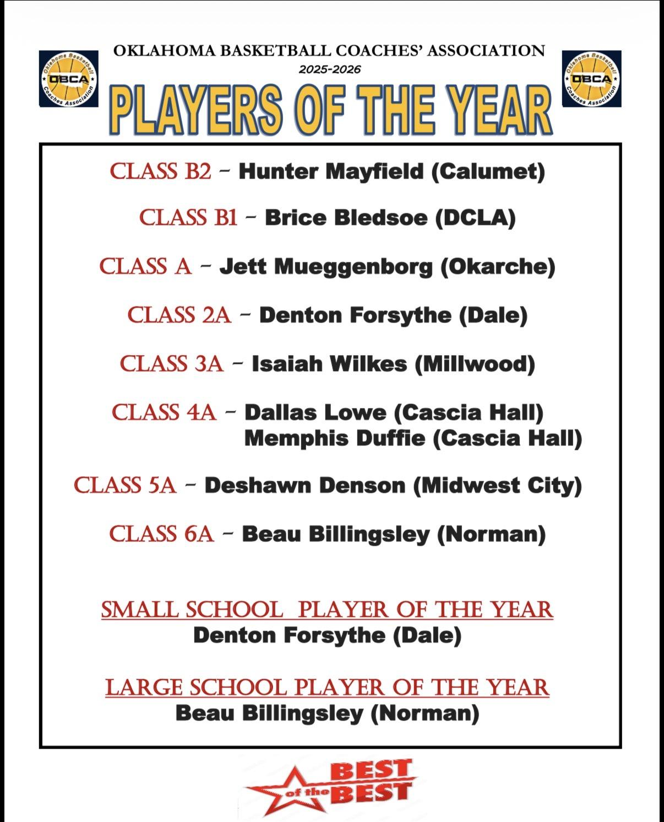

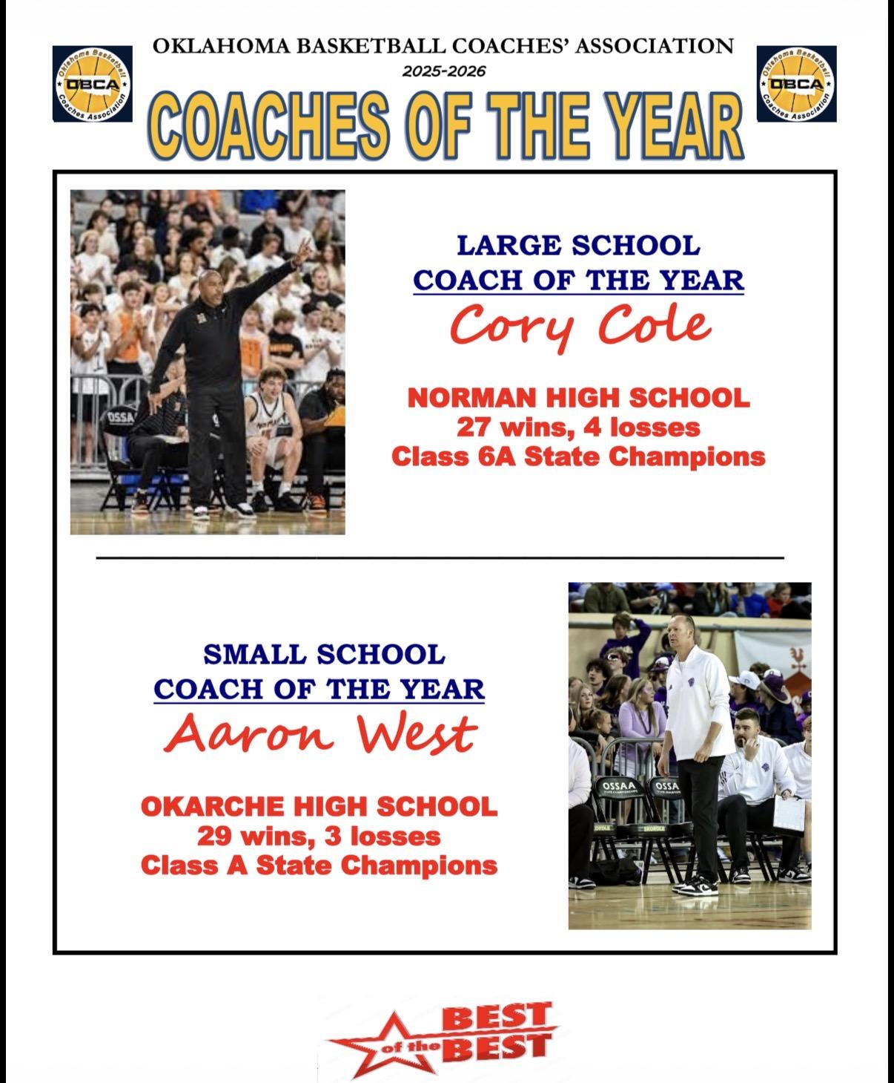

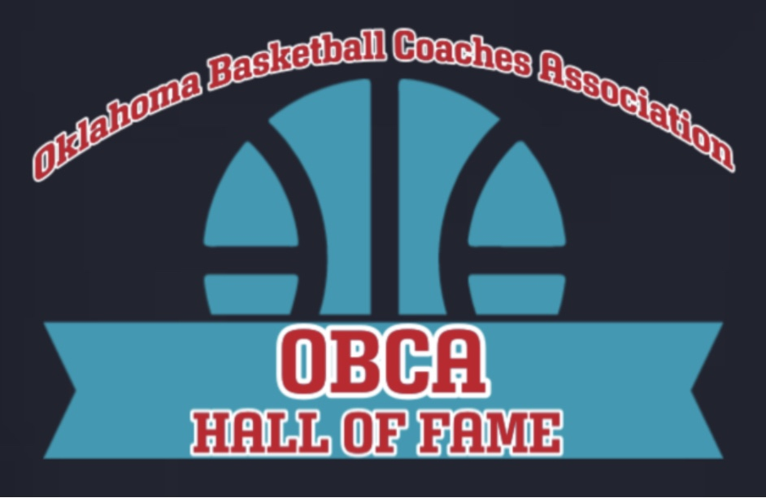

2026 OBCA Hall of Fame Class

David Baldwin, Clyde Eslick, Kirk Harris, Mark Vancuren, Terry West

12:00 pm Meet and Greet Reception for 2026 Hall of Fame Class (UCO Practice Gym)
- Refreshments and Hors d’oeuvres

12:30 pm 2026 Hall of Fame Induction Ceremony (UCO Practice Gym)
- Induction, presentation of plaques, and acceptance speeches

- Welcome - John Hardaway (OBCA Hall of Fame Director)

- Recognition of OBCA Hall of Famers in attendance

- Recognition of current OBCA board members in attendance

- 2026 Hall of Fame Class Introductions
David Baldwin
Clyde Eslick
Kirk Harris
Mark Vancuren
Terry West

1:45 pm Introduction of the 2026 Hall of Fame Class at mid-court (UCO Game Gym)
- Halftime of the 5A-6A All-Star game which starts at 1:30 p.m.
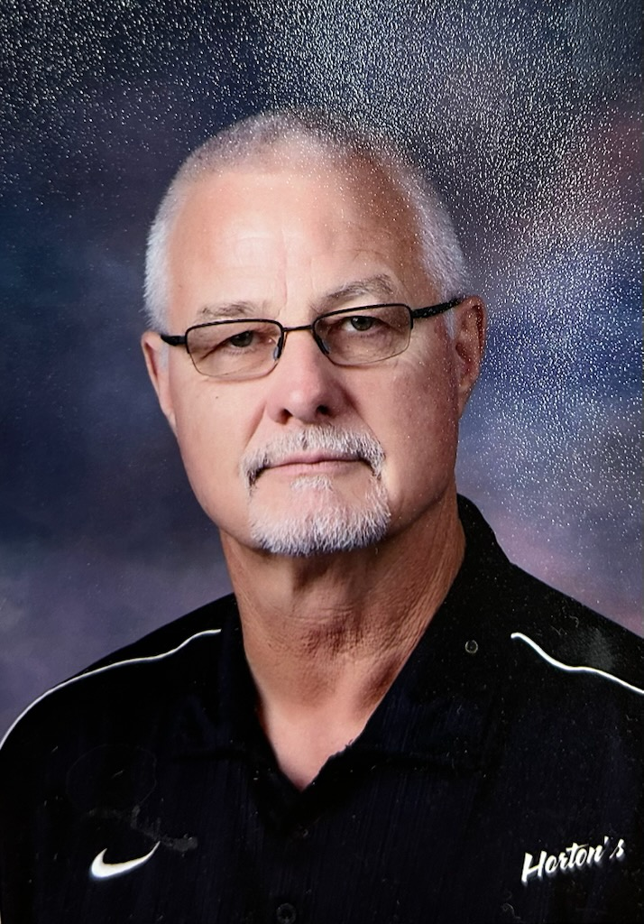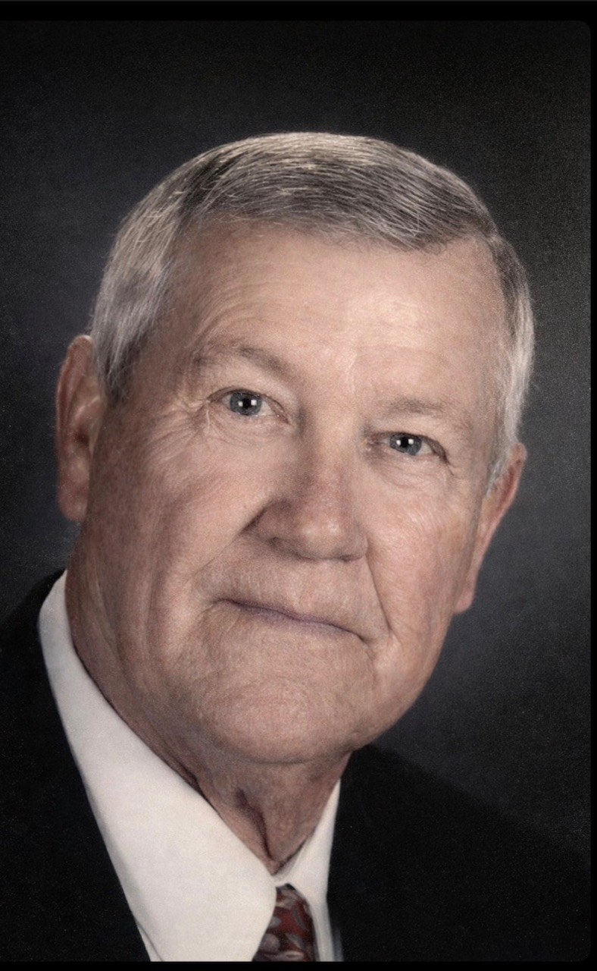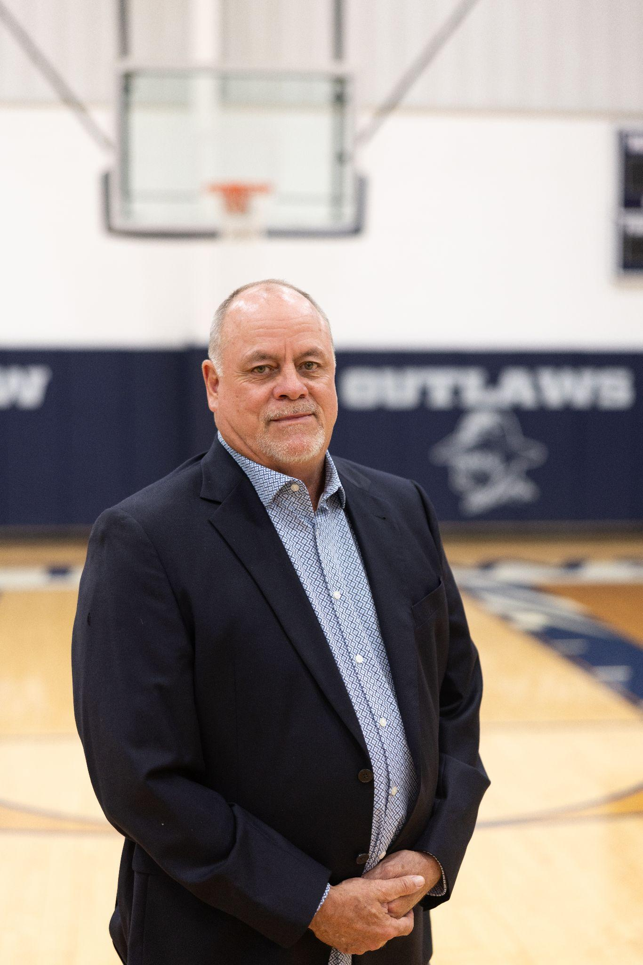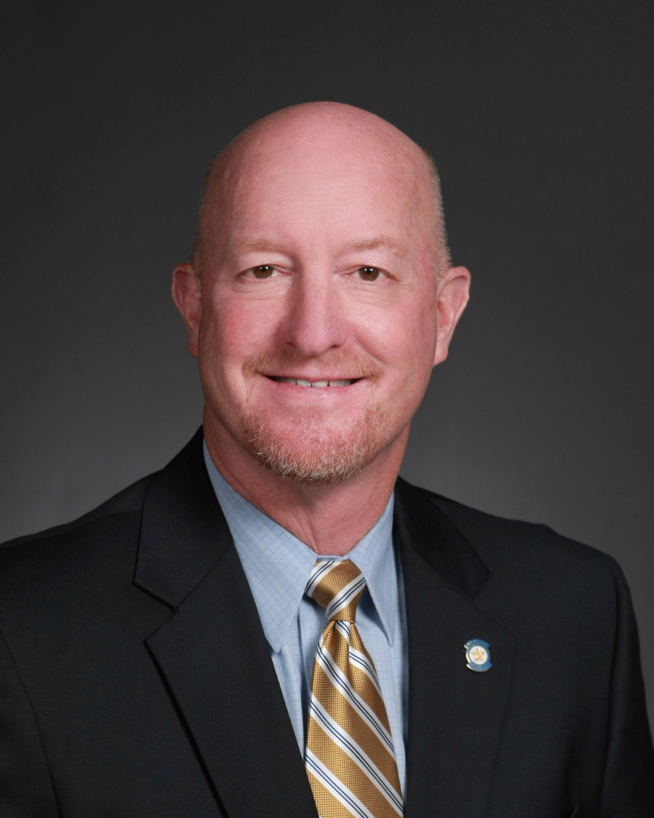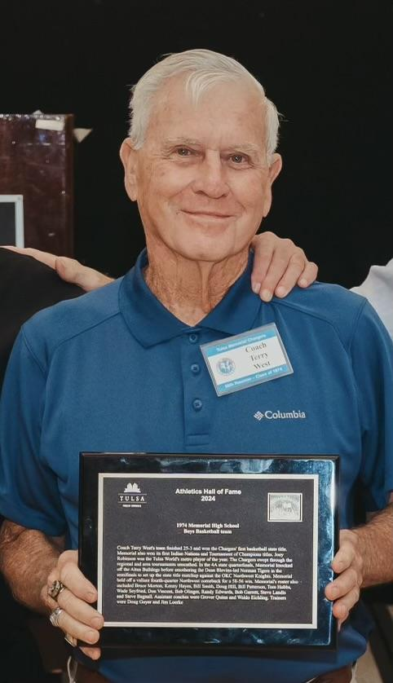

David Baldwin
David Baldwin won the Class A state championship at Erick-Sweetwater in 2001 and took the Bearcats to the state tournament in 1997. Baldwin led Fairview to the state tournament in 2005 and the semifinals in 2009. Baldwin was a head coach and member of the OBCA for 25 years. Baldwin's coaching career took him to Erick, Cheyenne, Erick-Sweetwater and Fairview compiling a career record of 435 wins and 246 losses. In 2001 Baldwin received numerous coaching awards including OBCA Coach of the Year, OCA Regional Coach of the Year and was the OCA all-state basketball coach. Baldwin also coached the OBCA all-star game and the Faith 7 game in 2013. Baldwin won 17 district championships. Baldwin coached 3 all-state players. Some of Coach Baldwin’s former players who went onto outstanding achievements themselves are Jacob Mayfield and Tyler Snowden who both have state championships as coaches themselves. Baldwin is a graduate of Fox High School and Southwestern Oklahoma State University. Baldwin spent 34 years in education.

Clyde Eslick
Clyde Eslick won two Class A state championships in 1975 and 1977 at Depew and was a state runner-up in 1972. Eslick also reached state tournaments in 1969 and 1974. Eslick’s coaching career took him to Milfay, Depew, and Bristow. Eslick compiled a career record of 270-82 in 14 years as a head coach and member of the OBCA. Eslick was also an assistant coach at Connors State College for three years. Eslick coached the OCA all-state basketball game in 1977 and was named the District 2 Coach of the Year. Eslick was named the Frisco Conference Coach of the Year 4 times. Eslick was a guest speaker at the OU basketball clinic and wrote an article for the Coaching Clinic magazine. Eslick won 7 district championships, 6 regional championships and 9 conference championships. Eslick coached 5 all-state players. Some of Coach Eslick’s former players who went onto outstanding achievements include Lawrence Washington, who won thew NAIA National Tournament at Drury and was named MVP, David Gerner, who was an assistant coach at Yava Pai Juco, and Mark Eslick, who was an assistant coach at Depew winning the boys state championship in 2004 and girls state championship in 2006. Eslick is a graduate of Gypsy High School and Central State College. Eslick spent 29 years in education.

Kirk Harris
Kirk Harris spent his entire 41-year career at Marlow and was the head boys coach for 27 of those years. Harris led the Outlaws to the state tournament 6 times. His teams reached the Class 3A quarterfinals in 1991, 1994, 1995, 2015 and 2021 and the semifinals in 2022. Harris compiled a career record of 469-246. Harris was the OCA large west boys’ basketball all-state coach in 1995, the Faith 7 coach in 2015 and coached the OBCA all-star teams in 2016 and 2022. While at Marlow his teams won 19 district championships, 5 regional championships and went to the area tournament 14 times. Harris' teams at Marlow also won 4 Academic State Championships. Harris was a faithful and active member of the OBCA during his career, serving on numerous OBCA, OCA and OSSAA selection committees and advisory boards. Harris was named the OCA Region 5 Coach of the Year 5 times in 1992, 1994, 2018, 2021 and 2022. In addition to his prowess as a boys coach, Harris was also named the OCA small west girls basketball coach and OGBCA middle west all state coach in 2012, as well as being named the Region 5 girls coach of the year in 2010. Some of Coach Harris’s former players who went onto outstanding achievements include Sam Hinkie, former GM for the Philadelphia 76’ers, JJ Smith and Scott Allen. Harris is a graduate of Mountain Park High School, Southwestern Oklahoma State University and East Central University. Harris has spent 41 years in education as a coach, teacher, and athletic director, all at Marlow High School.

Mark Vancuren
Mark Vancuren won the Class 4A state championship at Seminole in 1997. Vancuren led Owasso to the Class 6A semifinals in 2013 and state tournaments in 2014 and 2015. Vancuren was a head coach and member of the OBCA for 22 years. During his coaching career Vancuren coached at Westmoore, Seminole, Lawrence (KS), Norman, UT Pan-American University, Owasso and Sperry. Vancuren was an active OBCA member and served on the board as a region representative. Vancuren was named the OCA Region 6 Coach of the Year in 1997 and the Region 7 Coach of the Year in 2013. In 2012 Vancuren was named the OCA all-state basketball coach. Vancuren was also named the Frontier Valley Conference Coach of the Year twice in 2013 and 2015. Vancuren’s teams won 3 conference championships, 2 district championships and 7 regional championships. As an assistant coach, Vancuren helped Westmoore to a Class 5A State Runner-up finish. As an assistant coach for UT Pan-American University, they were the San Juan Shootout Champions beating the Baylor Bears. Vancuren coached 6 all-state players during his coaching career. Some of Coach Vancuren’s former players who went onto outstanding achievements included Shake Milton from Owasso, 1st team Parade All American and NBA player for the 76’ers and several other NBA teams, Ian Boylin from Norman who played in the Australian Professional League, and Mire Chatman at UTPA who is the all-time leading scorer for Americans in the history of Eurocup basketball. Vancuren is a graduate of Owasso High School, Oklahoma Baptist University and Northeastern Oklahoma State University. Vancuren spent 30 years in education.

Terry West
Terry West won the Class 4A state championship at Tulsa Memorial in 1974 and led 3 other Charger teams to the state tournament in 1975, 1980 and 1981. West led Tulsa Metro Christian to the Class 2A semifinals in 1992. West was a head coach for 21 years and a member of the OBCA for 30 years. As a head coach Terry West compiled a career record of 276-111. West was inducted into the Oklahoma Coaches Association Hall of Fame in 1993 and the Tournament of Champions Hall of Fame in 1993. West was named the Indian Nations Coach of the Year three consecutive times in 1974, 1975 and 1976 as well as the Oklahoma Six Conference Coach of the Year once in 1980. West was also named the Tulsa Tribune Coach the Year three times in 1974, 1975 and 1980. Coach West’s 1974 Tulsa Memorial State Championship team was the first team inducted into the Tulsa Public Schools Sports Hall of Fame in 2024. While at Tulsa Memorial his teams won 4 regional championships, 4 conference championships and 3 Tulsa All-City Metro championships. Coach West’s teams won the prestigious Tournament of Champions twice in 1974 and 1980. Some of Coach West’s former players who went on to have outstanding achievements include Danny Limes, state championship boys coach at Bishop Kelly, Kip Hardaway, Bob Garrett, Kevin Glanzer, Joey Robinson, Warren Lynn and Mike Hogue. Coach West played on his father’s 1958 Tulsa Rogers state championship team. Coach West led basketball camps in China for 9 years teaching fundamentals of basketball to Chinese youth. West is a graduate of Tulsa Will Rogers High School and Oklahoma State University. Terry West spent 30 years in education.

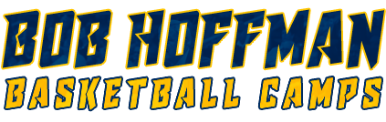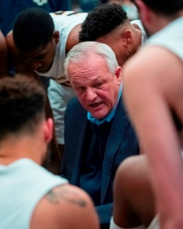

2026 SUMMER CAMPS

Team Camp June 22-24 Organized 9th, JV and Varsity Teams
Day Camp July 13-15 Boys and Girls entering 2nd-9th grade
Elite Camps August 8 Session 1 Boys entering 9th grade and up
August 19 Session 2

Please visit the Bob Hoffman Basketball Camp website for more information and registration
https://www.bobhoffmanhoops.com/

